Table 1
Volume of trading (including block trades):
- in April 2011
- in the last 12 months (May 2010 – April 2011)
- Number of open interest (NOI) at the end of April 2011.

No. | INSTRUMENT |  |  |  |  |  |  |  |  |  | NOI
 |  | VOLUME OF TRADING |  |  |  |  |  |  |  |  | (#)
 |  | (#)
 |  | APRIL |  |  | JANUARY-APRIL |  |  | LAST 12 MONTHS | 2010 | CHANGE | at the end of APRIL
 |  | 2011 | 2010 | CHANGE | 2011 | 2010 | CHANGE | (MAY'10 - APR'11) |  | (%) | 2011 | 2010 | CHANGE
 |  |  |  | (%) |  |  | (%) |  |  |  |  |  | (%)
1 | WIG20 CONTRACTS | 790 597 | 1 058 120 | -25.28% | 4 289 262 | 4 813 855 | -10.90% | 12 957 040 | 13 481 633 | -3.89% | 122 976 | 118 017 | 4.20%
2 | mWIG40 CONTRACTS | 2 027 | 2 910 | -30.34% | 10 332 | 13 546 | -23.73% | 29 784 | 32 998 | -7.74% | 856 | 1 084 | -21.03%
3 | SHARE CONTRACTS | 47 175 | 20 681 | 128.11% | 221 937 | 109 439 | 102.80% | 487 994 | 375 496 | 29.96% | 9 934 | 7 834 | 26.81%
4 | CURRENCY CONTRACTS | 8 130 | 5 867 | 38.57% | 37 537 | 34 422 | 9.05% | 122 190 | 119 075 | 2.62% | 3 364 | 1 676 | 100.72%
5 | WIG20 OPTIONS | 62 324 | 48 564 | 28.33% | 334 829 | 225 294 | 48.62% | 784 647 | 675 112 | 16.22% | 107 403 | 60 892 | 76.38%
6 | WIG20 PARTICIPATION UNITS | 4 304 | 3 116 | 38.13% | 10 117 | 14 429 | -29.88% | 31 928 | 36 240 | -11.90% | 14 035 | 13 206 | 6.28%
 | TOTAL | 914 557 | 1 139 258 | -19.72% | 4 904 014 | 5 210 985 | -5.89% | 14 413 583 | 14 720 554 | -2.09% | 258 568 | 202 709 | 27.56%

Source: WSE

Figure 1
Annual volume of trading (including block trades) in all derivative instruments listed on the WSE in 1998 – April 2011 (million instruments).

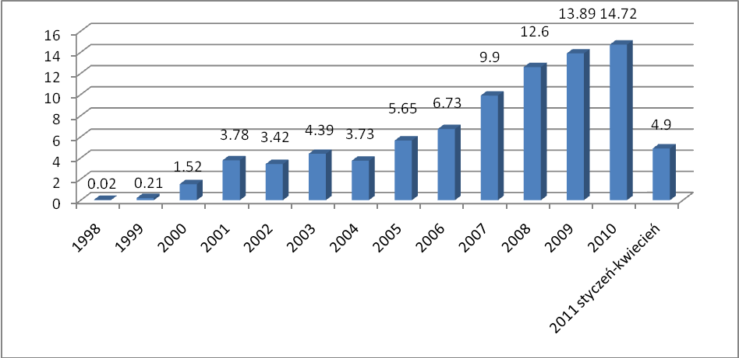

Source: WSE

Figure 2
Total number of open interest in all derivative instruments at year-end and at the end of April 2011 (thousand instruments).

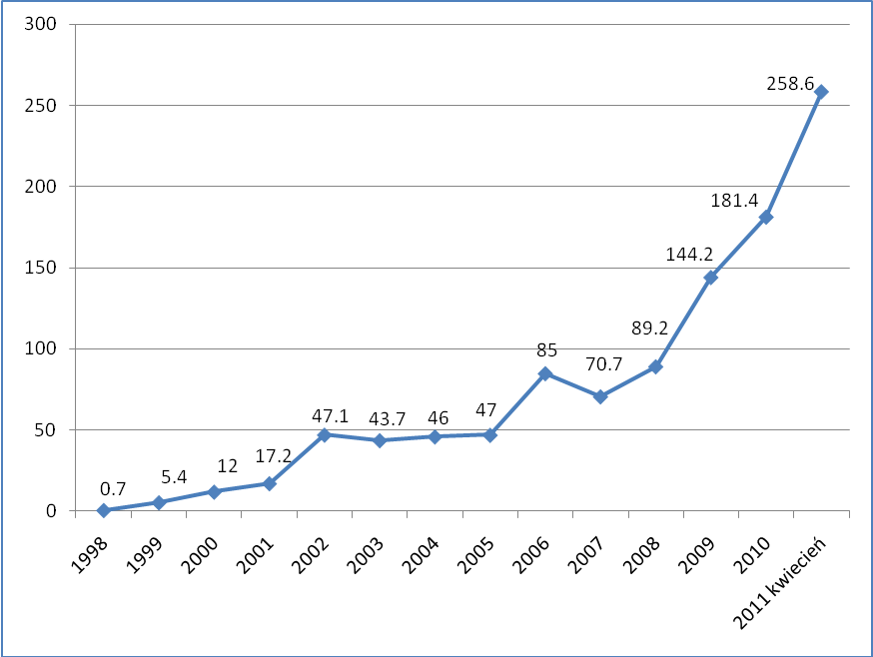

Source: WSE

